Kabeta Processor Design

|  |  |
| --- | --- |
| Date: | April 10, 2018 |
| Version: | 1.0 |
| Author: | Katherine White |
| Reviewer: | (N/A) |

# Introduction

## Description

Kabeta is a RISC processor based on the β Processor of MIT. Its main features and limitations include:

* Typical 5-stage Pipeline with Bypass
* Supervisor and User Modes
* Separate Instruction and Data Space
* Synchronous Single-cycle Access on-chip Instruction and Data RAMs

(for the sake of implementation in FPGA)

## Components

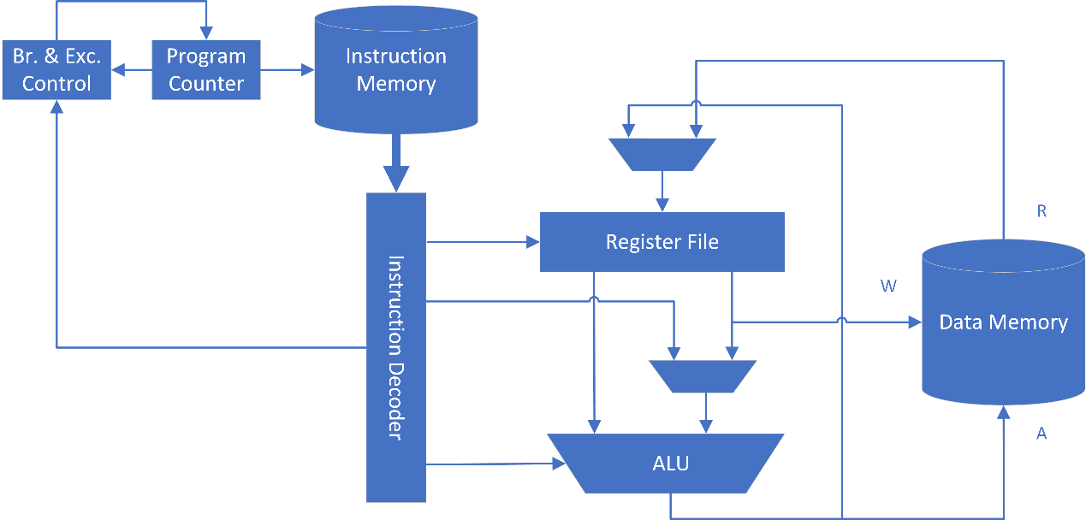

Kabeta mainly consists of Register File, Arithmetic and Logic Unit, Instruction Registers and Decoders, Branch and Exception Control, Program Counter, on-chip Data Memory and Instruction Memory.

## Block Diagram

[Click Here to Open Detailed Block Diagram](Design%20Diagrams%20-%20Detailed%20Block%20Diagram.png)

**IMPORTANT NOTE:**

* ALU in the diagram should contain an **output register**.
* Read-while-write behavior of Register File should be **write-through**, i.e. the output data should be the data to be written.

## References

* [MIT β Processor Specification](MIT6_004s09_lab_beta_doc.pdf)
* [MIT β Processor Summary](MIT6_004s09_lab_beta_summary.pdf)
* [Lecture Notes](https://ocw.mit.edu/courses/electrical-engineering-and-computer-science/6-004-computation-structures-spring-2009/lecture-notes/) of [MIT 6.004 Computation Structures](https://ocw.mit.edu/courses/electrical-engineering-and-computer-science/6-004-computation-structures-spring-2009/) ([L14](MIT6_004s09_lec14.pdf), [L22](MIT6_004s09_lec22.pdf), [L23](MIT6_004s09_lec23.pdf))

# Instruction Extension

## No Operation Instruction -- NOP (1A)

* Normal NOP

|  |  |  |  |  |
| --- | --- | --- | --- | --- |
| 31 26 | 25 21 | 20 16 | 15 1 | 0 |
| **01**1010 | 11111 | 00000 | 000000000000000 | 0 |

* Exceptional NOP (Internal Use Only)

|  |  |  |  |  |
| --- | --- | --- | --- | --- |
| 31 26 | 25 21 | 20 16 | 15 1 | 0 |
| **01**1010 | 11110 | 00000 | 000000000000000 | 1 |

**NOTE:** NOP instruction **does not** cause exceptions.

## System Service Instruction -- SVC (1C)

|  |  |  |  |
| --- | --- | --- | --- |
| 31 26 | 25 21 | 20 16 | 15 0 |
| **01**1100 | 00000 | 00000 | SVC_ID |

This instruction will cause System Service Exception.

# Bypass

## Bypass Paths

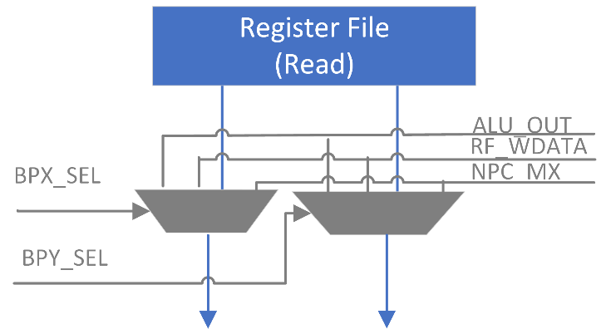

## Control Signals

ALU_OUT_SELX = (IR_EX.Opcode in {OP, OPC, LD, ST, JMP, B}) && (IR_EX.Ra != 31)

&& (IR_EX.Ra == IR_MA.Rc) && (IR_MA.Opcode in {OP, OPC})

NPC_MX_SELX = (IR_EX.Opcode in {OP, OPC, LD, ST, JMP, B}) && (IR_EX.Ra != 31)

&& (IR_EX.Ra == IR_MA.Rc) && (IR_MA.Opcode in {JMP, B, NOP})

RF_WDATA_SELX = (IR_EX.Opcode in {OP, OPC, LD, ST, JMP, B})

&& (IR_EX.Ra != 31)

&& (!ALU_OUT_SELX && !NPC_MX_SELX)

&& (IR_EX.Ra == IR_WB.Rc)

&& (IR_WB.Opcode in {OP, OPC, LD, LDR, JMP, B, NOP})

ALU_OUT_SELY = **(**(IR_EX.Opcode in {OP}) && (IR_EX.Rb != 31)

&& (IR_EX.Rb == IR_MA.Rc) && (IR_MA.OpCode in {OP, OPC})**)**

|| **(**(IR_EX.Opcode in {ST}) && (IR_EX.Rc != 31)

&& (IR_EX.Rc == IR_MA.Rc) && (IR_MA.OpCode in {OP, OPC})**)**

NPC_MX_SELY = **(**(IR_EX.Opcode in {OP}) && (IR_EX.Rb != 31)

&& (IR_EX.Rb == IR_MA.Rc)

&& (IR_MA.Opcode in {JMP, B, NOP})**)**

|| **(**(IR_EX.Opcode in {ST}) && (IR_EX.Rc != 31)

&& (IR_EX.Rc == IR_MA.Rc)

&& (IR_MA.Opcode in {JMP, B, NOP})**)**

RF_WDATA_SELY = **(**(IR_EX.Opcode in {OP}) && (IR_EX.Rb != 31)

&& (!ALU_OUT_SELY && !NPC_MX_SELY)

&& (IR_EX.Rb == IR_WB.Rc)

&& (IR_WB.Opcode in {OP, OPC, LD, LDR, JMP, B, NOP})**)**

|| **(**(IR_EX.Opcode in {ST}) && (IR_EX.Rc != 31)

&& (!ALU_OUT_SELY && !NPC_MX_SELY)

&& (IR_EX.Rc == IR_WB.Rc)

&& (IR_WB.Opcode in {OP, OPC, LD, LDR, JMP, B, NOP})**)**

# Pipeline Stall

Stall the pipeline when one of the source registers of the instruction at RR-Stage coincides with the target register of the load instruction at EX-Stage.

## Control Signals

STALL = **(**(IR_RR.Opcode in {OP, OPC, LD, ST, JMP, B*}) // Instrns Read Ra

&& (IR_RR.Ra != 31)

&& (IR_RR.Ra == IR_EX.Rc) && (IR_EX.Opcode in {LD, LDR})**)**

|| **(**(IR_RR.Opcode in {OP}) // Instrns Read Rb

&& (IR_RR.Rb != 31)

(IR_RR.Rb == IR_EX.Rc) && (IR_EX.OpCode in {LD, LDR})**)**

|| **(**(IR_RR.Opcode in {ST}) // Instrns Read Rc

&& (IR_RR.Rc != 31)

&& (IR_RR.Rc == IR_EX.Rc) && (IR_EX.Opcode in {LD, LDR})**)**

NOTE: Stall the pipeline as early as possible to disable less components.

## Implementation

Inject a Normal NOP instruction into EX-stage and disable Register File read, PC_RR, IR_RR, PC_IF and Instruction Memory.

**NOTE:** This implementation is a bit different with MIT β Processor.

## Mitigation

When writing programs, rearrange the instructions and put an instruction independent of the data to be loaded from memory exactly after the load instruction to eliminate pipeline stall.

# Exception

## Reference

Refer to Section 6. Extensions for Exception Handling in MIT β Processor Specification

## Supported Exceptions

|  |  |  |  |  |  |
| --- | --- | --- | --- | --- | --- |
| **Name** | **Code** | **Type** | **Source** | **Priority** | **Exc. Vector** |
| Reset | 000 | Reset | RST Pin | 0 (highest) | 8000_0000 |
| System Service | 001 | Trap | RR-Stage | 3 | 8000_0004 |
| Illegal Instruction | 010 | Fault | RR-Stage | 8000_0008 |
| Invalid Operation | 011 | Fault | EX-Stage | 2 | 8000_000C |
| Invalid D-Address | 100 | Fault | MA-Stage | 1 | 8000_0010 |
| Invalid I-Address | 101 | Fault | IF-Stage | 4 | 8000_0014 |
| Interrupt 0 | 110 | Interrupt | IRQ Pin | 5 (lowest) | 8000_0018 |
| Interrupt 1 | 111 | Interrupt | IRQ Pin | 8000_001C |

**NOTES:**

1) The MSBs of exception vectors indicate that the exception handlers will executed in the Supervisor Mode.

2) If instructions at multiple stages have caused exceptions simultaneously, only the exception in the highest priority should be processed.

## Exception Conditions

|  |  |
| --- | --- |
| **Name** | **Condition** |
| Reset | External reset signal (active LOW) |
| System Service | SVC instruction |
| Illegal Instruction | Instructions with Opcode = 6’b00x_xxx or 6’b010_xxx |
| Invalid Operation | Unused Operate Class Opcodes, MUL/MULC, or DIV/DIVC |
| Invalid D-Address | Out of data memory address range |
| Invalid I-Address | Out of instruction memory address range |
| Interrupt 0/1 | External interrupt signal |

## Interrupt Request and Acknowledge

* External interrupts are level triggered.
* Interrupt number is read from IID pin.
* Acknowledge is a pulse of one clock cycle’s duration.

**NOTE:** The above signals (IRQ, IID and IACK) cross clock domains.

## Implementation

When an Exceptional NOP instruction arrives at WB-Stage, write register XP = PC_WB, which is the instruction address plus 4.

### Reset Processing

* Reset all Instruction Registers (i.e. load Normal NOPs).
* Reset all Program Counters (i.e. load 32’h0000_0000 address).
* Set ExcAddr = reset exception vector, and select ExcAddr as next PC value.

**NOTE:** Synchronization of external RST signal is necessary.

### Trap and Fault Processing

When a trap or fault occurs:

* Replace the instruction which has caused the exception with an Exceptional NOP instruction (by asserting ExcIF/ExcRR/ExcEx/ExcMA).
* Replace the later instructions in the pipeline with Normal NOP instructions (i.e. flush the pipeline).
* Jump to the exception handler.

**NOTE:** Traps and Faults could be nested, as long as XP is stored onto stack in the exception handlers.

### Interrupt Processing

When an interrupt occurs:

* Wait until Supervisor bit is cleared (i.e. PC_IF.S == 0).
* Replace the instruction at IF-Stage with an Exceptional NOP instruction (by asserting ExcIF).
* Jump to the exception handler.

**NOTE:** Interrupts could not be nested with other exceptions.

### Traps/Faults in Supervisor Mode

In Supervisor Mode, traps and faults will put the processor into an undefined state.

# Branch

## Branch Delay Slots

There are 2 branch delay slots. The instructions in the branch delay slots are executed whether the branch is taken or not.

**NOTE:** Fill the branch delay slots with two instructions which are always executed exactly before branch or NOP instructions in the program.

## Supervisor Mode

Only the JMP instruction is allowed to clear the Supervisor bit but not set it, and no other instructions may have any effect on it.